BULLETIN OF AFFILIATION

Quran Account Inc. Quarterly, Vol. 26, No. 1 March -2007
I
S
L
A
M
QURAN
AFFILIATION NEWS
By Allah's Grace, this issue of the Bulletin will reach a total of 6,923 Muhtadoon (converts to Al-Islam); this is the total number since the project started in February 1985. During the last three months 69 Muhtadoon have enrolled in the project
Because of the cost and the great demands, the organization cannot fill the needs of each and every request, and in some cases suggest that new Muhtadoon seek help from other Islamic organizations.
────══════·══════────

OUTSTANDING PERSONALITIES

معاذ بن جبل
الصحابي الجليل

MU’ADH IBN JABAL
The Great Sahaabi
(The following is to share with you the writing of a Muslim Mu'min; may Allah bless the writer, whose name is not published, in compliance with the policy of this publication. This writing has been edited extensively)

Mu’adh ibn Jabal was a young boy at the advent of Islam. He was a native of Medina, noted for his intelligence, quick wit, competency in speech, and a prominent standing among people. He is described as an handsome individual with dark eyes and eye lashes, teeth very white, and hair Afro-like in its curliness. His physical appearance was very eye catching.

Mu’adh became Muslim on the hands of Musab bin Umair in Medina. He traveled to Mecca (to participate in Aqaba agreement) with 71 other people. In that occasion he embraced Muhammad (pbuh) and pledged to uphold the religion of Islam. On returning to Medina, the legend says, he formed a small posse of youth from his community who vowed to destroy the Idols kept in Medina. It was because of Mu’adh and his posse that Amr ibn al-Jamuh, who was one of the leaders of Banu Salamah tribe became Muslim.
Amr al-Jamuh used to have a valued wooden idol similar to the ones noble men possessed, except for the fact that he took explicit care of it in every way. He used to clothe it with silk, paint it, and perfume it, and he called it Manah.
Mu’adh under the cover of darkness took the idol way. Next morning the owner visited the idol to perfume it, but to his shock it was missing. He spent the day looking for the idol with no success until finally he found it planted, face down, in the hole where the tribe left its refuse and human waste. Amr al-Jamuh was deeply offended and angrily said “Woe to you who dare attack our lord in the middle of the night!” and after cleaning it, he said to the idol “Oh Manah if I only knew who did this to you, I would humiliate him with all my might.”
The next night Mu’adh and the boys did the same thing but this time they planted it firmly in a different sewer hole. Amr woke up and to his shock the idol was missing again. He searched until he found it in the sewer hole, and cleaned it pleading to the idol to watch for the people who dare do this. This was repeated a 3rd time, so Amr said, “Oh Manah! I cannot protect you , so I leave my sword so that you protect yourself.” While saying that, he hung the sword around the neck of the idol and left. That night Mu’adh and the posse sneaked in, took the sword and tied it to the neck of a dead dog, and dumped the idol head first into the septic hole. When Amr woke up he searched for his idol and found it tied to the dog, headfirst in a waste hole. This proved a wake up call for Amr, after which he declared his Islam and became a very prominent Muslim.

When Muhammad arrived in Medina, Mu’adh was always around him until he became one of the top readers of Quran and master at Islamic knowledge. This was supported by Yazid ibn Qutayb when he said: “I entered a mosque in Humms (Syria) and saw a young man with Afro-like hair with people gathered around him. I asked about him and was told he was Mu’adh bin Jabal. Abu Muslim al-Khawlani also said: “I came to a mosque in Damascus and saw older men conversing in religion and every time they had an argument they resorted to Mu’adh ibn Jabal for the correct answer.”
Muhammad (pbuh) said Mu’adh is well versed in matters of Halal and Haram. He was also one of the six called scribes of Qurans’ revelations. Other scribes were Abu Ayub al-Ansari, Ubayy ibn Ka’b, Mu’adh ibn Jabal, Abu al-Dardaa’, and Ibadah ibn Al-Saamit. The Sahaaba used to gather around Mu’adh to learn the halal and haram at his hand; once Khalifa Omar (r) said of him: “unique is his birth, and without his help Omar would have perished. “
Mu’adh was one of the few who issued Fatwa while the Prophet was still alive, just as did Ali, and Ubayy ibn Ka’b, and Zayd ibn Thabit.
The Prophet of God sent Mu’adh to Yemen as a jurisprudent, and asked him : “How would you judge if you were presented with a problem?” Mu’adh answered, “I look into the book of God.” The Prophet then asked: “Suppose you do not find the solution in the book of Allah.” Mu’adh answered, “then I look into the Tradition of the Prophet.” The Prophet then asked, “and if it is not in the Book or Tradition?” Mu’adh answered, “I will endeavor my opinion.” The Prophet replied with relief: “Praise be to God who had accorded merit to the messenger of the Messenger of God!”
Mu’adh was one of the companions who memorized the Holy Quran, and collected it at the time of the Prophet. It was such that the Prophet said, “Read the Quran at the hands of one of four:
1) Abdullah bin Mas’ud,
2) Salim Mowla Abu Hudhayfah,
3) Ubayy ibn Ka’b, and
4) Mu’adh Bin Jabal.”
Mu’adh used to frequently urge people to seek knowledge, since knowledge renders you in awe of Allah, and knowledge’s seeking is worship, and its discussing is glorification, and the search for it is Jihad, and by its educating others is charity, and its offering is closeness to God, because knowledge features the Halal and Haram.
Mu’adh died at a young age of 38, (18thH year) due to the widespread epidemic of plague at that time!.
────══════·══════────

The following Khutba was delivered at the Islamic Education Center, Potomac MD by Maulana Akbarian. It may be used as a sample by any would-be Imam for Salat Al-Jumu'ah. Similar Khutbas will follow in the forthcoming Bulletins of Affiliation.
KHUTBA OF JUMU'AH
Comparative Study about Tawhid

Let us all practice Taq’wa (piety and righteousness), and revere Allah as He should be and obey His divine commands. Let us be heedful of our choices in this life and their likely consequences in the hereafter. Let us be aware of our final destination, our eventuality and departure into the everlasting life.

Jesus the Messiah said nothing about there being Three Divine Persons in Godhead. The Messiah’s concept of God was in no way different from that of earlier Israelite Prophets, who had always preached the Oneness (Unity) of God and never the Trinity. It is a fact that the Messiah himself never mentioned the trinity. Jesus merely echoed the earlier Prophets when he said, quoting the Gospel according to Mark 12:29,30:
“The first of all the commandments is, Hear Israel, the Lord, our God is one Lord; and that Thou shall love the Lord thy God with all thy heart, and with all thy soul, and with all thy mind, and with all thy strength.”
The Holy Quran also says in Surah 19 (Maryam), Ayah 35:
“It befits not the Majesty of God to take a son unto Himself. Limitless is He in His Glory!  When He decrees a thing to be, He but says unto it: Be! and it becomes.” | مَا كَانَ لِلَّهِ أَن يَتَّخِذَ مِن وَلَدٍ سُبْحَانَهُ إِذَا قَضَى أَمْرًا فَإِنَّمَا يَقُولُ لَهُ كُن فَيَكُونُ
Reason and common sense are again on the side of Islam. Philosophy, Irfan, and theology tell us that no Being from whom another Being can come out and for such Being to enlist as a separate individual, yet become his equal and partner, and can be regarded as perfect.
Islam presents a concept of God free from anthropomorphic or mythological fantasies. Islam affirms the uniqueness of God. Islam says Allah (God) has no partner in His Godhead. God is One in Person and One in Substance: the two being indistinguishable. God is Self-sufficient, on whom all depend yet He depends not on anyone. God is the Creator:
- God Creates and Nourishes all,
- God is the All-Good, the Almighty, the All-knowing,
- God is the All-Loving, the All-Merciful,
- God is the Eternal and the Infinite.
- God neither begets (gives birth to any), nor is begotten (was given birth to).
- Nothing can come out of God while becoming His equal and partner in Godhead.
- In this world every imaginable reality is a limited reality, and has a boundary beyond which it cannot extend its existence. Only God is such that He has no limit or boundary, for His reality is absolute and He exists in His Infinity. This means that God’s Being does not depend upon and is not in need of any causes or conditions.
Once a person asked Imam Ali if he asserted that God was One. In answer, Imam Ali said:
ان القول فی ان الله واحد علی اربعة اقسام:
  - : فوجهان منها لا یجوزان علی الله عزّ و جلّ
  - ووجهان یثبتان فیه
فامّا اللذان لا یجوزان علیه فقول القائل: واحد یقصد به باب الاعداد، فهذا ما لا یجوز؛ لانّ ما لا ثانی له لا یدخل فی باب الاعداد، اما تری انه کفر من قال: ثالث ثلاثة
وقول القائل هو واحد من الناس ویرید به النوع من الجنس فهذا ما لا یجوز علیه؛ لأنه تشبیه وجلّ ربنا عن ذلک وتعالی.
وامّا الوجهان اللذان یثبتان فیه، فقول القائل:
هو واحد، لیس له فی الاشیاء شبه، کذلک ربّنا
وقول القائل انه عز و جل احدی المعنی؛ یعنی به انه لا ینقسم فی وجود ولا عقل ولا وهم؛ کذلک ربّنا عز وجل.

“To say that God is One has four meanings: Two of those meanings are incorrect and two are correct. The incorrect meanings are:
- The first incorrect meaning is that when a person says: “God is One” he thinks in terms of numbers. He is therefore at error, because the Being of God has no second, thus it cannot enter into the category of numbers. Don’t you see that those who say God is the third of a Trinity [i.e., the Christians] fell into infidelity?
- The second incorrect meaning is to say that an entity belongs to a species or a member of a species. This does not apply to God, for it implies something is similar to God: But God is above all similarities, for He is unique.
As to the two meanings which are correct when applied to God:
- The first correct meaning is to say that God is One in the sense that there is no likeness unto Him, since only God possesses such uniqueness.
- The second correct meaning is to say that God is One in the sense that there is no multiplicity or division conceivable in Him, neither outwardly nor in the mind nor in the imagination. Only God possesses such a Oneness (unity)."
Ali has also said:
To know God is to know His Tawhid (Oneness). | معرفته توحیده

This means that to prove that the Being of God is unlimited and infinite suffices it to prove His Oneness, for to conceive a second for the Infinite is impossible. There is therefore no need for any other proofs. The Holy Quran says in Surah 112 (Ikhlaas), Ayah 1-4:
“Say: He is God the One: God the eternally besought of all. He begets not, neither is He begotten. And there is none that can be compared with Him” | قُلْ هُوَ اللَّهُ أَحَدٌ اللَّهُ الصَّمَدُ لَمْ يَلِدْ وَلَمْ يُولَدْ وَلَمْ يَكُن لَّهُ كُفُوًا أَحَدٌ
The theological science of the Holy Quran is the oneness of God. It simply declares by saying: “There is no divinity except Allah” This motto has been repeated in the Quran more than sixty times in different words and expressions. Most of the monotheistic verses of the Quran rest on the concept of “the Oneness (Unity) of God, meaning: Tawhid be it in Commandment and Direction” or “Tawhid in Worship and Obedience” to one God.
The earliest revelations of the Quran were often about “Tawhid”, which began with reference to “God’s creations and commandments”. The Quran says in Surah 96 (Alaq), Ayah 1-5:
“Proclaim! In the name of Thy Lord who has created,  He created man out of germ-cell [a mere clot].  Proclaim! For Thy Lord is Most Bountiful!  Who has taught the use of Pen, taught man what he knew not.” | اقْرَأْ بِاسْمِ رَبِّكَ الَّذِي خَلَقَ خَلَقَ الْإِنسَانَ مِنْ عَلَقٍ اقْرَأْ وَرَبُّكَ الْأَكْرَمُ الَّذِي عَلَّمَ بِالْقَلَمِ عَلَّمَ الْإِنسَانَ مَا لَمْ يَعْلَمْ

The Quran addresses the disbelievers over the weakness of their “man–made” gods and encourages them to reflect and think over this point so they may comprehend this obvious fact. The Holy Quran relates in Surah 13 (al-Ra’ad), Ayah 16:
“Say: who is the Lord of the heavens and the earth?  Say: [It is] Allah.  Say: [Why then] do you take for your protection, instead of Him, guardians who neither can benefit nor avert harm, even to themselves?  Say: Can the blind and the seeing be deemed equal? —Or can the depth of darkness and the light be deemed equal?  Or do they [really] believe that there are other divine powers beside Allah, who create the likes of what Allah creates, so creation seemed to them all alike?  Answer: “Allah is the Creator of all things, and He is the One, the All Dominant Almighty.” | قُلْ مَن رَّبُّ السَّمَاوَاتِ وَالأَرْضِ قُلِ اللّهُ قُلْ أَفَاتَّخَذْتُم مِّن دُونِهِ أَوْلِيَاء لاَ يَمْلِكُونَ لِأَنفُسِهِمْ نَفْعًا وَلاَ ضَرًّا قُلْ هَلْ يَسْتَوِي الأَعْمَى وَالْبَصِيرُ أَمْ هَلْ تَسْتَوِي الظُّلُمَاتُ وَالنُّورُ أَمْ جَعَلُواْ لِلّهِ شُرَكَاء خَلَقُواْ كَخَلْقِهِ فَتَشَابَهَ الْخَلْقُ عَلَيْهِمْ قُلِ اللّهُ خَالِقُ كُلِّ شَيْءٍ وَهُوَ الْوَاحِدُ الْقَهَّارُ
The Verses of Quran (Surah 30 (al-Room): 40, Surah 25 (al-Furqan): Ayahs 1-4, Surah 35 (Faatir): Ayah 3, Surah 39 (al-Zumar): Ayah 43) all emphasize the point about Creations and Commandments, that is the creation of the universe and its governance. If we think correctly and logically we will come to the conclusion that all our supplications and worship belong exclusively to God and none else (glory be to Him!).
According to the Quran the unique and consistent order that governs the universe is an obvious proof of uniqueness and Oneness of the Creator and the Controller of the universe. And we are asked to consider such marvelous design and coherent system to realize the unity in creation. Verses of Quran like Surah 2 (al-Baqarah): Ayahs 164-163, and Surah 6 (al-An’aam): Ayahs 94-99, and Surah 10 (Yunus): Ayahs 3-6 and a number of other verses draw the attention of man towards the evident signs in the orderly system of the universe which indicate the Oneness of the Creator.
The Holy Quran refutes the doctrine of polytheism (Surah 23 (al-Mu’minoon): Ayahs 91-92) that if there were many creators, then their relation with the universe would be such as to lead to anarchy because of conflicts in their commands.
God alone, the Omnipotent and Omniscient, knows every thing and is able to do every thing by His Will. God created the world according to a special design and within its system He assigned tasks to certain things, thus creating certain phenomena. But all such created things are subordinate to God’s Will and Purpose; and they act as God’s agents. These may be regarded as the Laws of Nature.
These agents perform their duties obediently. They operate under their Lord’s Command and do not deviate a bit from His path and are completely under the Divine control. The Holy Quran says in Surah 7 (al-A’raaf), Ayah 54:
“And (He created) the sun and the moon and the stars:  All governed by Laws under His command”  God’s Will and Command are at work behind all affairs, e.g. creation, administration, and sovereignty; everybody acts in the way God intends to it. | إِنَّ رَبَّكُمُ اللّهُ الَّذِي خَلَقَ السَّمَاوَاتِ وَالأَرْضَ فِي سِتَّةِ أَيَّامٍ ثُمَّ اسْتَوَى عَلَى الْعَرْشِ يُغْشِي اللَّيْلَ النَّهَارَ يَطْلُبُهُ حَثِيثًا وَالشَّمْسَ وَالْقَمَرَ وَالنُّجُومَ مُسَخَّرَاتٍ بِأَمْرِهِ أَلاَ لَهُ الْخَلْقُ وَالأَمْرُ تَبَارَكَ اللّهُ رَبُّ الْعَالَمِينَ
Imam Ali has once said: (See Furoo’ al-Kaafi, Vol. 8, Page 384.)
“Allah has sent Muhammad (pbuh) in Truth to shift people from worshipping individuals to worshipping Him (glory be to Him),  to commit themselves to Him, to obey Him, and to be in His Guardianship and none else.” | انّ الله تعالی بعث محمداً صلّی الله علیه واله وسلم بالحق لیخرج عباده من عبادة عباده الی عبادته ومن عهود عباده الی عهوده ومن طاعة عباده الی طاعته ومن ولایة عباده الی ولایته
Allah (swt) asks us to obey His Directives and Commands, and to seriously pay attention to the fate of our Islamic Ummah.
In the end, we ask Allah to help us in doing these orders and forgive us our sins and stamp out our bad deeds and take our souls in the company of the righteous.

For the end of the 1st part of the Khutba, read Surah Al-Asr, take a short intermission, then start the 2nd part of the Khutba with a short Du’aa.

The Muslim community is founded on a number of basic principles. One of the most important of these is Tawhid (Unity). This unity is not an association of people on the basis of color, race or tribal affiliation, but a voluntary association of faith. Every person who believes in Allah, the hereafter, the angels and the chain of Prophets are in the Ummah of Islam, no matter the place they come from, their color, status, nationality, or other things. The fundamental criteria are: a) faith and b) doing good deeds.
Prophet Muhammad (pbuh) in a Hadith says:
The manner of the love between the believers is like that of a body, it suffers if any of its components is sick. | مثل المؤمنین فی تواددهم وتراحمهم کمثل الجسد اذا اشتکی بعض تداعی له سائر اعضاء جسده بالحمّی والسهر
The question is: How can we unite the Muslim’s Ummah nowadays. As you know one of the outstanding achievements our Prophet accomplished upon entering Medina was to establish the virtual brotherhood between “Ansaar” of Medina and the Immigrants of Mecca who preceded him “Muhaajiroon”. This made the Muslim Ummah a tightly knit community more or less like committed brothers to the welfare of the Ummah at large. Thus they became successful in helping the Prophet (pbuh) reach his goals. In Islam’s point of view, Mu’mins (the faithful Muslims) are like brothers to each other. Quran says in Surah 49 (al-Hujuraat), Ayah 10:
“The believers are but a single brotherhood” | إِنَّمَا الْمُؤْمِنُونَ إِخْوَةٌ...
At the advent of Islam the entire Arabia presented a scene of battle fields and was literally in a quagmire of mischief of the utmost degree. People of that peninsula had always been at loggerheads with one another and their hearts were filled with rancor. However, Islam taught them the value of mutual love as a part of its basic program. The Holy Prophet quoted the Quran Surah 49 (al-Hujuraat, Ayah 10.)
"The believers are but a single brotherhood,  so make reconciliation and peace between your contending brothers and fear Allah,  that you may receive Mercy." | إِنَّمَا الْمُؤْمِنُونَ إِخْوَةٌ فَأَصْلِحُوا بَيْنَ أَخَوَيْكُمْ وَاتَّقُوا اللَّهَ لَعَلَّكُمْ تُرْحَمُونَ
At the time of his death Imam Ali advised his children as follows: (See Nahjul Balaaghah letter 47)
O family! Practice piety,  keep your affairs organized  and make peace among yourselves,  because I have heard your grandfather, the Holy Prophet saying that  Allah regards making peace between two persons as better than offering prayers and fasting for one year. | اوصیکما وجمیع ولدی ومن بلغه کتابی بتقوی الله ونظم امرکم وصلاح ذات بینکم  فانی سمعت جدکما رسول الله (ص ) یقول:  صلاح ذات البین افضل من عامة الصلوة والصیام
We ask Allah (swt) to help us apply these orders and we ask Allah to grant us that which He has promised us by His messengers and save us from any disgrace on the Day of Judgment, verily Allah never fails His promise.

Finally, let us read Surah Al-Nasr with a short Du’aa to close the Khutba
────══════·══════────

KHUTBA OF JUMU’AH & PAMPHLETS
A book containing 40 Khutbas of Jumu’ah has been published; written and arranged by Dr Hashim. These Khutbas were delivered by Dr Akbarian in the IEC. The book comes in 258 pages, of highly educational value and is highly recommended. Cost $10.00+$3.00 for shipping=$13.00.
Also Pamphlets are available in 10-11 pages each, written about various Islamic subjects on an advanced level. They explain both the Shi'a and the Sunni approach to that subject, thus they are of value for distribution in mosques and other centers of learning.
Madh'habs #1 Development and Evolution
Madh'habs #2 Congenial Coexistence
Madh'habs #3 Ah'kaam of Salat
Madh'habs #4 Hadith: Analysis and Overview
Nahjul Balaaghah #1 An Overview
Nahjul Balaaghah #2 About Ahlul Bayt
The Quran refers to Ahlul Bayt
Prophet Muhammad (pbuh) refers to Ahlul Bayt
Karbala: Chain of Events
Marriage and Family In Islam
────══════·══════────

QURANS
Qurans with translation and commentary by Yusuf Ali are available by now. They are hard bound and in beautiful Medina script, for a total of $15.00 per copy, (this includes the $5.00 shipping charges).
To order, the prisoners should write to:
Quran Account Inc.
c/o A.S. Hashim, MD
6407 Tuckerman Lane
Rockville, MD 20852
────══════·══════────

Web Site on the Internet
A web site is available on the internet, was published by Dr. Hashim on August 1, 2005.
The address is www.islamicbooks.info. It consists of the following:
- Series of Islamic Books for Beginners
- Madh’habs: A Shi’a Sunni Dialogue
- Khutbas of Jumu’ah
- PowerPoint Slide Shows
- Nahjul Balaaghah in PowerPoint
- Material about Muharram and various subjects.
- Many high caliber links: Sunni and Shi’a content
The site is user friendly, contains beginner, mid-level, and advanced material. The added links will give you advanced level information about Quran, Hadith, and numerous other subjects. English, as well as other languages. Material is suitable for research, writing articles, as well as general information about Islam. Visits to this site reach 1200 to 2,000 for each month, and the number of unique visitors has reached a grand total of 3,514 so far.
────══════·══════────

FREE BOOKS TO PRISON LIBRARIES
Chaplains asking for free Islamic books including Quran/s (Commentary by Yusuf Ali) to be used by the libraries of prisons should write to:
Quran Account Inc.
c/o A.S. Hashim, MD
6407 Tuckerman Lane
Rockville, MD 20852
────══════·══════────

IN WRITING YOUR LETTER
Please write your letter in Ink. Many letters come to us written in pencil (which are very hard to read). Write clearly, spaced every second line, in ink, and state what you want clearly. Make sure you write your address inside the letter too. This will remove any trouble in understanding your request.
────══════·══════────

TO SUBSCRIBE:
To subscribe for this free publication, simply write to:
Quran Account Inc.
c/o A.S. Hashim, MD
6407 Tuckerman Lane
Rockville, MD 20852
Let your friends and acquaintances know of this publication and see its worth and value to them.
────══════·══════────

ANSWERS TO MULTIPLE CHOICE QUESTIONS
The following is correct answers to the multiple choice questions that appear in this issue of the Bulletin of Affiliation. Brothers and sisters do your own grading. Don't send the answers to anyone, please.

ISLAMIC ETHICS
Question | Answer |  | Question | Answer
1. | a | | | 21. | d
2. | b | | | 22. | a
3. | a | | | 23. | d
4. | d | | | 24. | c
5. | a | | | 25. | a
6. | c | | | 26. | b
7. | c | | | 27. | a
8. | d | | | 28. | a
9. | c | | | 29. | c
10. | c | | | 30. | c
11. | a | | | 31. | d
12. | c | | | 32. | c
13 | d | | | 33. | d
14. | a | | | 34. | b
15. | d | | | 35.
16. | d | | | 36.
17. | b | | | 37.
18. | d | | | 38.
19. | b | | | 39.
20. | c | | | 40.

IN ALLAH'S NAME, EVER GRACIOUS, EVER MERCIFUL
QUESTIONS ABOUT ISLAMIC ETHICS

- Can good deeds be done with various kinds of intentions?
  - Yes, except evil intentions.
  - Should be done only with good intentions.
  - Yes with any kind of intention.
  - a and c above.
- The Holy Quran teaches that the true winner is the one who has purified himself. What is the first step towards purifying ourselves?
  - Being good to our parents.
  - Solemn intention to follow Allah's commands.
  - Follow Allah's commands often.
  - Follow the example of Prophet Muhammad.
- "A truly pure heart with good measure of mercy will lead to the Garden of Bliss." Is that part of being a good Muslim?
  - Yes, since this is a Hadith.
  - Yes, since it is in the Quran.
  - Yes, since it is both in the Quran and a Hadith.
  - Yes, it is a good saying by my dad.
- Why does Allah command us in the Holy Quran to hold to the truth and to be straightforward.
  - Because we will benefit.
  - Though the truth is hard, it is better that we stick to it.
  - The society will benefit in the long run.
  - All the above.
- According to a Hadith, what are the signs of hypocrites?
  - He who lies, breaks promises, cannot be trusted.
  - A mean person who lies and criticizes.
  - One with double personality who hurts others.
  - A person who brags about himself all the time.
- Allah commands us to be "honest in our thoughts as well as in our deeds." Why is that?
  - It is bad to be honest in thoughts and dishonest in deeds.
  - Honesty is more important than our deeds.
  - Virtue commands honesty in thoughts and deeds.
  - Dishonesty in thoughts and deeds is the worst thing.
- Allah commands us in the Holy Quran to fulfill our contracts and promises. Why is that?
  - A true Muslim must be honest.
  - Would be best for the society.
  - a and b above + good for us.
  - Likes us to be perfect + b.
- Can you give us an example about the trusteeship of Muhammad (pbuh)?
  - Enemies and friends called him "the trustworthy."
  - People trusted him with their valuables as if he were a bank.
  - During Hijrah, the trusted valuables had to be returned.
  - He entrusted it to Ali (a.s.) who returned b above.
- Prophet Muhammad (pbuh) urges us to be kind, and so does the Quran. Why should we be kind?
  - Kindness is a mark of faith.
  - Kindness is a component of godliness.
  - Kindness springs from love + the above.
  - Kindness is done to gain respect of others.
- How difficult is it to treat others with kindness?
  - It is very difficult.
  - Not difficult if we want to be kind.
  - It depends on the situation.
  - It is cowardly to be brutal, brave to be kind.
- How loving can we be towards the orphans and the needy?
  - Should be very loving + b and c.
  - Orphans and the needy should not be the target of ridicule.
  - Understand their predicament and act accordingly.
  - We can give them enough care + c.
- Does Allah favor those who are kind and loving?
  - Yes, all kinds of loving people.
  - Yes, the faithful, kind, and loving people.
  - The kindness and love done for His sake.
  - All the above.
- How does it feel to be arrogant?
  - As if with a touch of temporary insanity.
  - Temporary bigness.
  - Being inconsiderate of others.
  - Discourtesy + a and b above.
- Can a believer be a person with bad manners?
  - He is not applying his faith well.
  - He is a poor believer.
  - He is flunky.
  - He is wishy washy.
- What is meant by "Humility and Courtesy are acts of Piety"?
  - To be pious a person reaches the heights of faith.
  - True humility is hard, that is why it is an act of piety.
  - Humility comes through inheritance + a.
  - All the above except c above.
- Prophet Muhammad (pbuh) said "The riches are from the contentment of the heart."
  - When there is no greed, there is contentment.
  - Happiness is a state of mind, a feeling.
  - Often a materially rich person is worry-wart and unhappy.
  - Riches can emanate from faith + above.
- What troubles can a greedy person have?
  - Hurts others, sometimes very much.
  - Hurts himself & others depending on kind of greed.
  - Hurts Islam.
  - Most people are greedy, no trouble at all.
- What are the good targets for showing compassion?
  - Compassion to the community.
  - Compassion to individuals.
  - Prevailing good feeling.
  - All the above.
- Are Muslims to have compassion towards all creatures of Allah?
  - No, that is impossible.
  - Ideally, yes, since compassion has to prevail.
  - Only if we can.
  - b and c above.
- Prophet Muhammad (pbuh) said "The best Jihad is when you stand up for the truth in the face of a malicious ruler." How is that?
  - It is easy to speak up in such a situation.
  - It is very hard to speak up in such a situation.
  - It might be life threatening to do so.
  - All of the above.
- What does the Holy Quran say about forgiveness?
  - "Hold to Forgiveness and Command to what is Right."
  - "If you Forgive and Overlook, verily Allah is Compassionate."
  - "Verily Allah is most forgiving and merciful."
  - All the above.
- Self-control is a form of self conquest. Is it a form of Jihad?
  - Self-control is hard, it often is a form of Jihad.
  - Yes it is on rare occasions.
  - No, it is not, why should it be?
  - Jihad is no more than self-control.
- "He is not strong or powerful he who runs people down." Why did Prophet (pbuh) say that?
  - Criticism is practiced more by psychologically weak people.
  - Running people down is cowardly in a way.
  - Criticism hurts peoples' feelings.
  - All above + it leads to retaliation.
- "Envy eats up good deeds." What did Prophet Muhammad mean by that?
  - Envy is destructive, will cost the person demerits.
  - Envy will reduce the value of the person.
  - a and b above + yet not all envy is bad.
  - a and b above + all envy is bad.
- The Quran says that suspicions is often a major sin. What is meant by that?
  - Often suspicion proves Satanic, thus a major sin.
  - Being suspicious is stupid.
  - Suspicion is always Satanic, it is a sin.
  - Being suspicious is insane + a.
- Why does the Holy Quran command us not to spread scandal about others?
  - Scandal is always disastrous.
  - Scandal can cause extreme injury to others.
  - Scandal is as bad as suspicion.
  - All the above.
- "To abuse a Muslim is evil, and to fight him is unbelief." What does this Hadith teach us?
  - The high level of Islamic behavior + b and c.
  - The love that should prevail among Muslims.
  - The brotherhood among the Muslims.
  - Only in theory, cannot be practiced.
- How will the Islamic world be if Muslims carry on their responsibilities?
  - Ideal, attractive, superb.
  - No different than at the present time.
  - Will be just OK.
  - The whole world becomes Muslim.
- If disagreement shows up among Muslims, what are we supposed to do?
  - Favor the strong party to gain favors.
  - Make peace to gain attention.
  - Make peace for the sake of Allah.
  - Judge justly, punish the arrogant party.
- "To be a good faithful, you should love for your brother what you love for yourself." What does this Hadith mean?
  - Do your utmost to help other Muslims.
  - Intend to do good for Muslims always.
  - a and b + binding Muslims in the strongest way.
  - a and b above + binding Muslims somehow.
- The Holy Quran promises rich rewards to those who are charitable and give?
  - Easier to receive than to give.
  - Giving in charity is a sign of love.
  - a and b above.
  - c above but for the sake of Allah.
- What kind of charity is good in your eyes?
  - Helping others when they ask us to do so.
  - Helping others when help is needed.
  - Help can be material or through deeds + b.
  - Only if I want to help.
- Why does the Holy Quran command us to be moderate in our dealings and deeds?
  - Moderation is the optimum.
  - Moderation is less likely to lead to trouble.
  - Moderation does not exhaust our capacity.
  - a and b above.
- Why aren't the learned people on equal footing with others in the eyes of the Holy Quran?
  - Islam prefers only the learned people.
  - The learned people earn their higher status.
  - The learned people are superior by nature.
  - Islam does not like non-thinking people.

Darul Salam Update دار السلام

Darul Salam Center, Inc.,
P.O. Box 4355,
Rockville, MD 20849,
Phone: (301)738-2343 (703)941-4779, Fax: (301)738-2337. Website: darulsalam.org

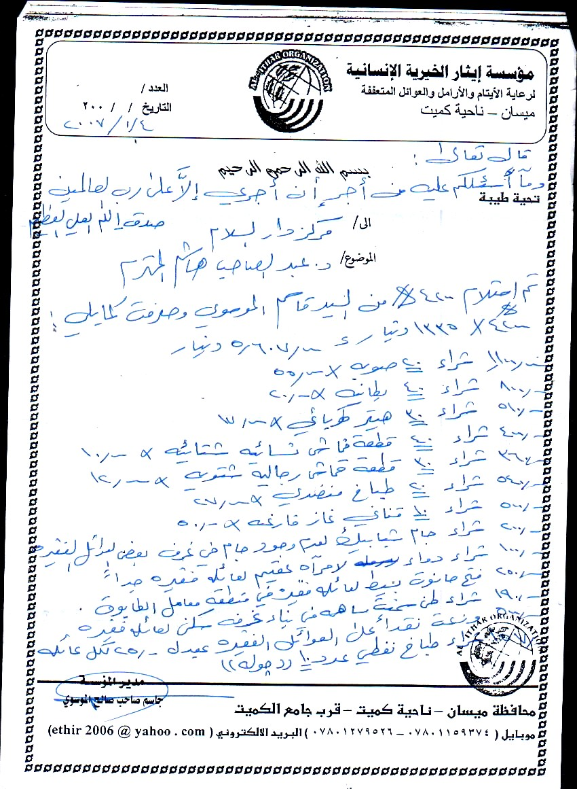 | 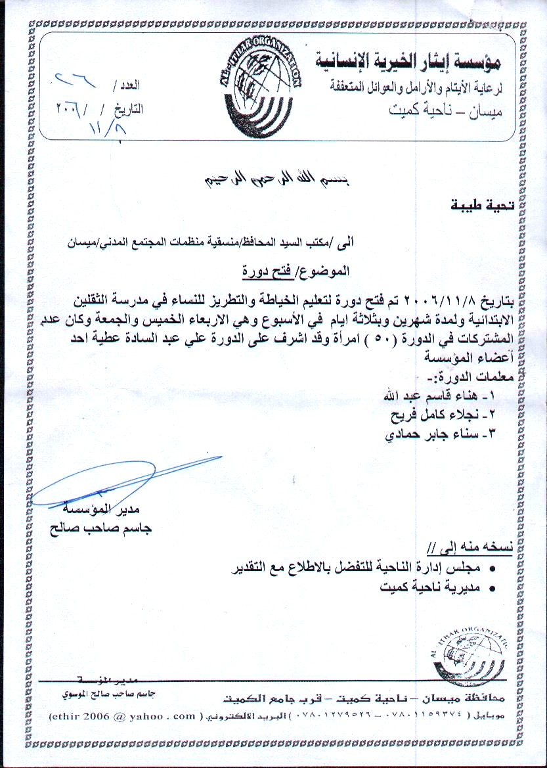

Funds to help Widows and Orphans:
Shown above are two receipts from Iraq. They show how the money was spent to help the widows and orphans. The receipt on your right shows training of 50 widows in the business of sewing, so that they can become self-sufficient. The receipt on the left shows items bought and distributed to the widows: Blankets, table stoves, heaters, food, cash, and other simple things.

Muharram
Darul Salam, along with Imam Ali’s Center commemorated Muharram during the 10 days of Ashuraa, and 3 days afterwards. Since the center is quite large, one particular space was reserved for Darul Salam’s use, whereby the speeches were given in Arabic, the Nauha in Arabic, and poetry about the occasion in Arabic. Attendance varied from 60 to 150 individuals. At one occasion TV channels joined to record the commemoration for broadcasting.

COMMENTARY ABOUT
ONE OF THE 99 SUBLIME ATTRIBUTES OF ALLAH
One sublime attribute of Allah (swt) appears in this issue of the Affiliation, and will continue to do so until all 99 are fully described.

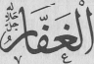
AL-GHAFFAR
Allah is the one who accepts repentance and forgives. If one is guilty of the disruption of harmony within oneself and around oneself, which is perhaps the greatest sin, and one realizes, wills and begs Allah's help not to do it again, if one begs with tears of shame and asks Allah al-Ghaffar for forgiveness, Allah will forgive him and perhaps transform his sin into a good deed.
A sinner is like a poor fellow who has fallen into a sewer. What is the first thing that he must do? He cannot face others in that state, nor can he stand himself. He must wash and cleanse himself, unless he is insane, not realizing his offensive state. The soap and water with which to wash one's interior is repentance. Woe to those who do not see nor smell the dirty stench filling their interiors!
Repentance is between each person and Allah; no one else need hear it. It need not even be pronounced. Allah knows what passes through one's heart. Repentance must also be accompanied by a firm intention not to do the sinful act again. The sign of acceptance of your repentance and the accordance of forgiveness by Allah al-Ghaffar, is that He will not let you repeat that sinful act again.

Abd al-Ghaffar is the one who is given the quality of forgiving a fault, of covering and hiding a fault from others, of having the compassion of not seeing a fault as a fault. He does this in cases and to persons whom Allah, the Forgiver, has forgiven.
HADITH OF THE PROPHET (pbuh):
➢ Ali (a.s.) narrated that the Prophet (pbuh) said,
“Allah had enjoined on the affluent Muslims [to give] from their wealth a certain amount to satisfy the needy; so that the poor are not to suffer when they are hungry or be without adequate attire, [except when caused by how the wealthy deals with them]. Indeed, in such cases Allah will charge the wealthy a grave account and punish them very heavily.”

SAYINGS OF IMAM AL-HASAN, the 2nd Imam
➢"I am surprised at him who is discreet about what he eats, but does not ponder at what enters his mind; as a result, spares his stomach of things that would harm it, but allows into his heart that which would ruin it."

